Name:__________________________________ Date:_______________ Period:_____ Mr. Hagewood
Intro to Sociology
Ch. 9: Deviance - Notes & Analysis
Deviance vs. Crime
- Deviance = the recognized violation of cultural norms.
- Crime = the violation of a society’s formally enacted criminal law.

- How are these two terms both similar and different?
- What are some examples of each?

Initiation: Crime & Deviance: An Introduction (External Documents)

Social Control
- Attempts by society to regulate people’s thoughts and behavior.
  - Why are people interested in social control?

- Criminal Justice System
  - A formal response by police, courts, and prison officials to alleged violations of the law.

Deviance: Personal or Social?
In a well-reasoned but brief paragraph, thoughtfully respond to the following question:
- Do you think that deviance is mostly a matter of personal issues (individual choice) or social issues (conditions)? Why?
____________________________________________________________________________________________________________________________________________________________________________________________________________________________________________________________________________________________________________________________________________________________________________________________________________________________________________________________________________________________________________________________________________________________

Structural-Functional Theories of Deviance

- Durkheim: deviance is a necessary component of social organization

How could that be?

He says:
  - ____________________________________________________
  - ____________________________________________________
  - ____________________________________________________
  - ____________________________________________________

- Robert Merton: Strain between culture’s emphasis on wealth/success and the lack of opportunities to get rich/successful

Which components of Merton’s theory (see the diagram to the right) are most beneficial (or least harmful) to society?
________________________________________________________________________________________________________________

What is a weakness of this approach?
____________________________________________________________________________________
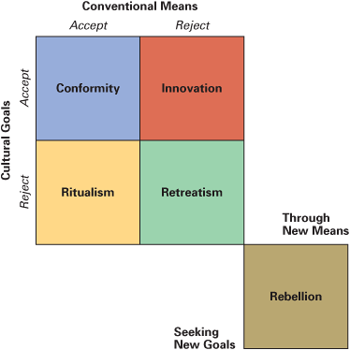

- Cloward & Ohlin
________________________________________________________________________________________________________________________

- Cohen
____________________________________________________________________________________________________________________________________________________________________________________

- Anderson
____________________________________________________________________________________________________________________________________________________________________________________

- What do all of these theorists have in common?
________________________________________________________________________________________________________________________________________________________________________________________________________________________________________________________________________________________________________________________________________________________________________

Symbolic-Interaction Theories of Deviance
Labeling Theory | Definition
 | Primary Deviance
 | Secondary Deviance
 | Stigma
 | Retrospective & Projective Labeling
 | Labeling Difference as Deviance
Hirschi’s Control Theory  People are likely to conform if they possess the following: | Attachment
 | Opportunity
 | Involvement
 | Belief
Which of these items most makes you conform? Why?

Social-Conflict Theory & Deviance

- People we define as deviants are more likely to be the powerless in society.
  - ____________________________________________________________________________________________________________
  - ____________________________________________________________________________________________________________
  - ____________________________________________________________________________________________________________

- Think of three (3) laws that disproportionately benefit the powerful at the expense of the powerless.
  - ______________________________________________________
  - ______________________________________________________
  - ______________________________________________________

Sidewalk by Mitchell Duneier (See Video Questions)

Types of Crime

- Crime is two parts: the act and criminal intent
  - Crimes against the person (violent crimes)
  - Crimes against property
  - Victimless crimes (people who commit them are both offenders and victims)

- Specific Branches of Crime
  - White-Collar Crime
  - Corporate Crime
  - Organized Crime
  - Hate Crimes
  - Deviance & Gender

What can you gather from the map & chart regarding major crime (both violent and property) in the United States? Why is this important?
____________________________________________________________________________________________________________________________________________________________________________________________________________________________________________________________________________________________________________________________________________________________________________________________________________________________________________________________________________________________________________________________________________________________
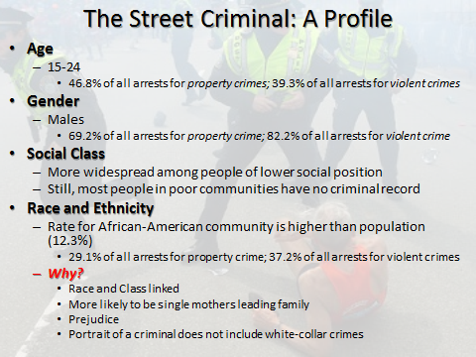

Crime in Global Perspective

- Crime rate in the United States is high by world standards
  - Violent crimes: rate is several times higher than in Europe
- Why?
  - Emphasis on individual economic success
  - Incredible cultural diversity
  - Vast economic inequality
  - High level of gun ownership (controversial)

- Do you think that controlling gun ownership has the potential to reduce deadly violence in the United States?
____________________________________________________________________________________________________________________________________________________________________________________________________________________________________________________________________________________________________________________________________________________________________________________________________________________________________

Why do we have a death penalty? What purpose does it serve in society?

Debate Arguments For/Against the Death Penalty
In Favor of Death Penalty | Against Death Penalty
Where do you stand? Who had the most compelling argument?

U.S. Criminal Justice System
- Due Process
  - The justice system must work within the bounds of the law
    - Fair notice of the proceedings
    - A hearing on the charges with the ability to present a defense
    - A fair judge or jury
- Police
  - Primary point of contact
  - (Smith and Visher) When arresting, police consider: seriousness, victim’s wishes, cooperation level of suspect, familiarity with suspect, audience, race of suspect
- Courts
  - Lawyer vs. lawyer; most cases solved through plea bargaining
Punishments
- Retribution
  - ____________________________________________________________________________________________________________

- Deterrence
  - ____________________________________________________________________________________________________________

- Rehabilitation
  - ____________________________________________________________________________________________________________

- Societal Protection
  - ____________________________________________________________________________________________________________

- Which do you prefer? Which type of punishment does the United States tend to prefer? What makes you think so?
____________________________________________________________________________________________________________________________________________________________________________________________________________________________________________________________________________________________________________

Does our system work?

- Criminal recidivism
  - Repeat offenders
  - ~75% of all prisoners in state prisons have been jailed before
- Non-prison options:
  - Probation
    - Can remain in community under certain conditions
  - Shock Probation
    - Mix of jail and probation
  - Parole
    - Follows release, sometimes early

- Why are these “options” offered?
- Could we make the system work better? How?
____________________________________________________________________________________________________________________________________________________________________________________

Prison Population in the U.S. (See External Document)

