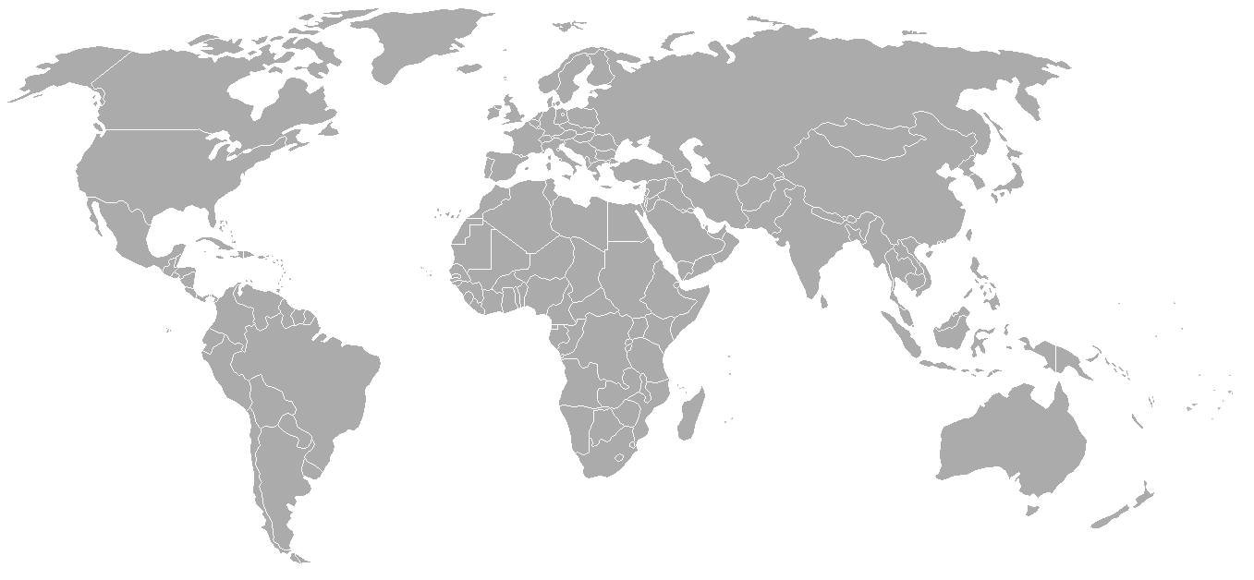
Name: ________________________ Date: ___________
Cold War Conflicts
Key:
- _____________
- _____________
- _____________
- _____________
- _____________
- _____________
- _____________
- _____________
- _____________
- _____________
- _____________
- _____________
Task: Identify the countries on the map where the cold war conflicts took place (use the timeline from the previous page). Label and shade in these countries (create a key)

Task: Using the map and the timeline answer the following questions.
1. What region(s) of the world were the majority of the Cold War conflicts located in? Why do you think they were located in these region(s)?
________________________________________________________________________________________________________________________________________________________________________________________________________________________________________________________________________________________________________________________________________________________________________________
2. Many of the Cold War Conflicts were located in third world nations. Why do think many of these conflicts
________________________________________________________________________________________________________________________________________________________________________________________________________________________________________________________________________________________________________________________________________________________________________________
3. What Cold War Theories helped ensure that these conflicts took place?
________________________________________________________________________________________________________________________________________________________________________________________________________________________________________________________________________________________________________________________________________________________________________________________________________________________________________________________________________________________________________________________________________________________________________

